Build and Deploy hadoop word count program using SBT

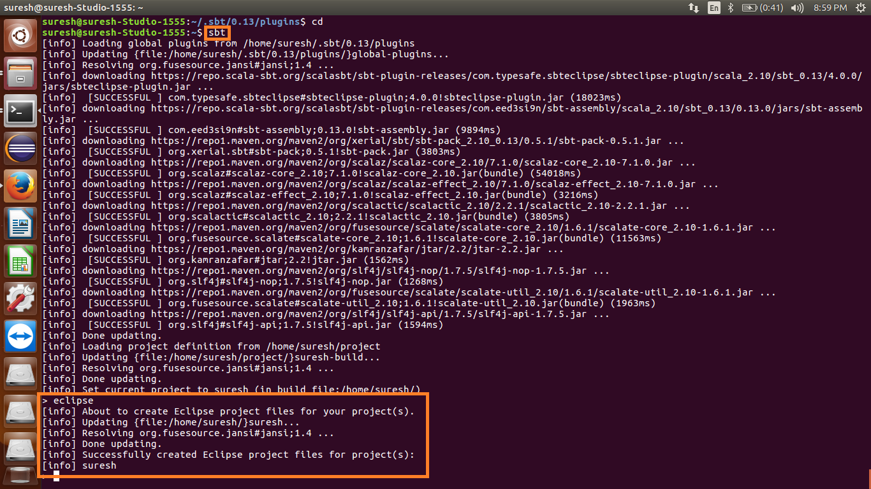

Providing specification in build.sbt file:

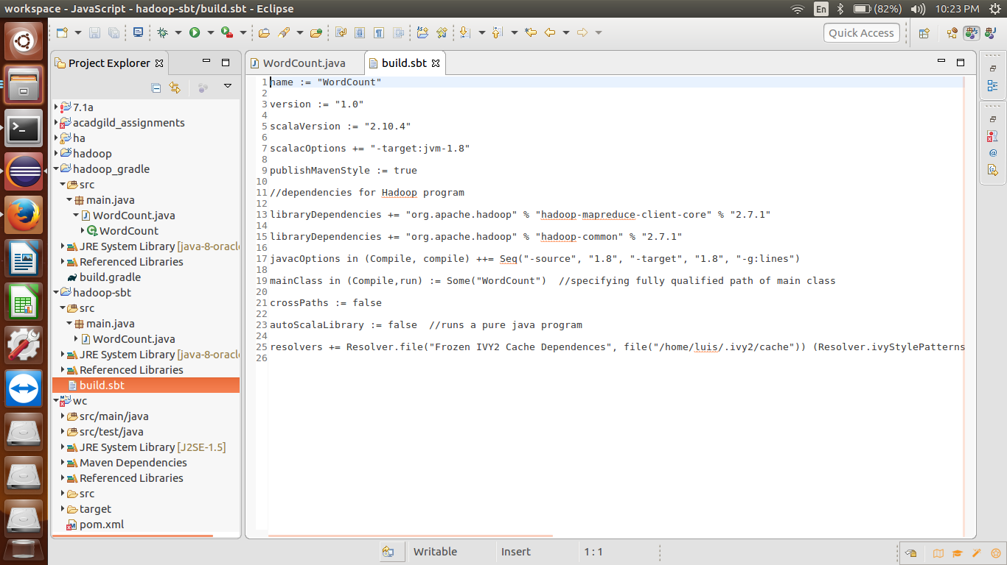

Word count program:

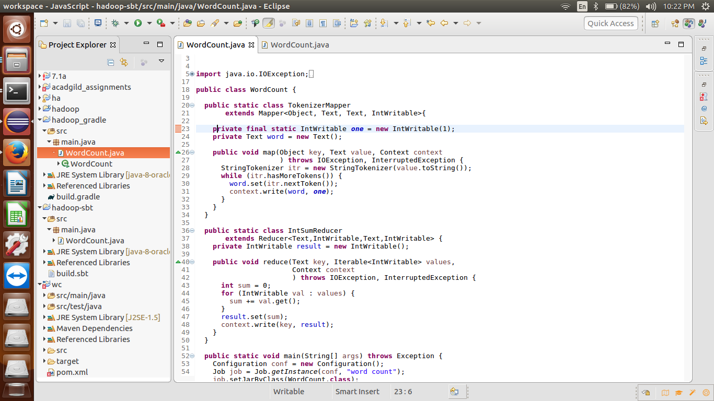

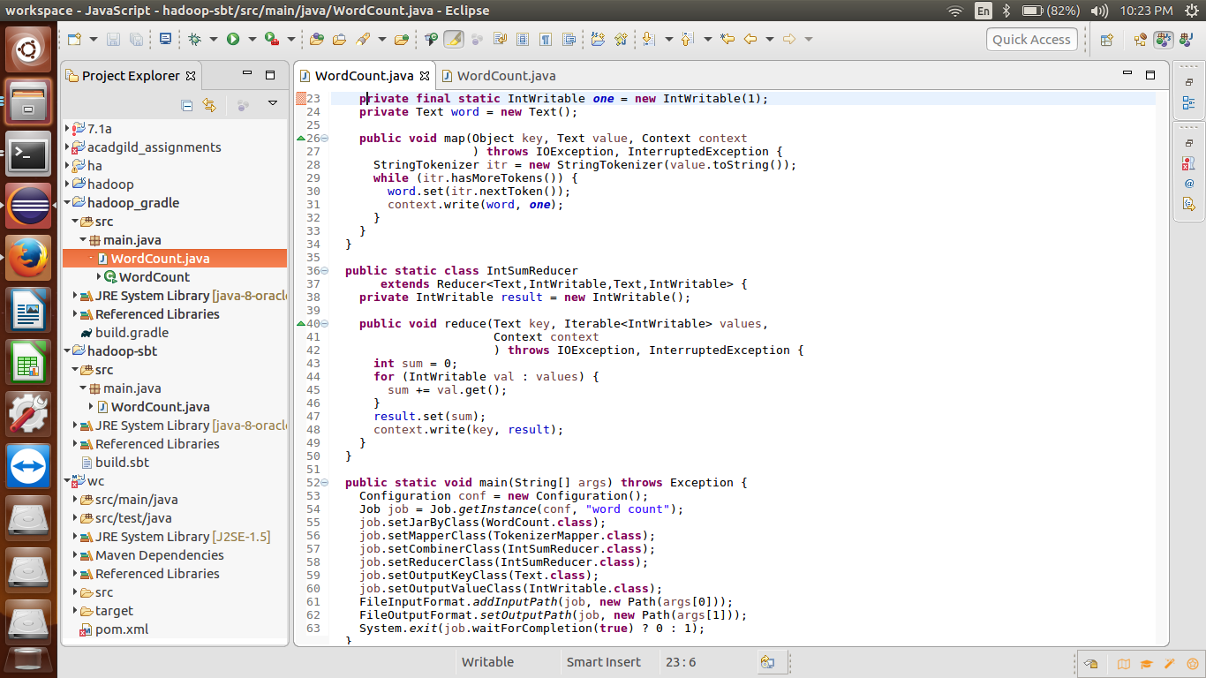

SBT Compile command:

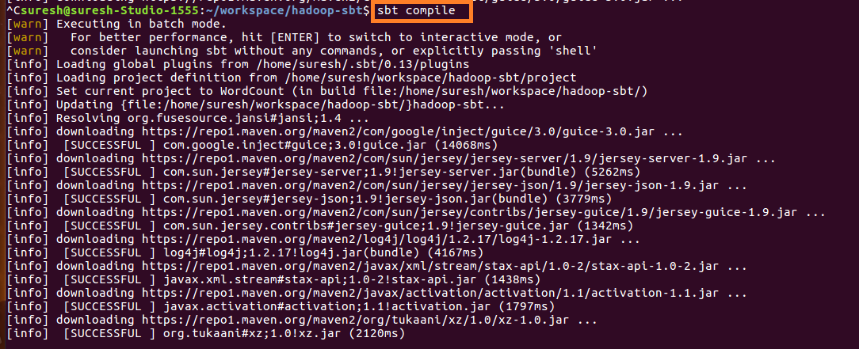

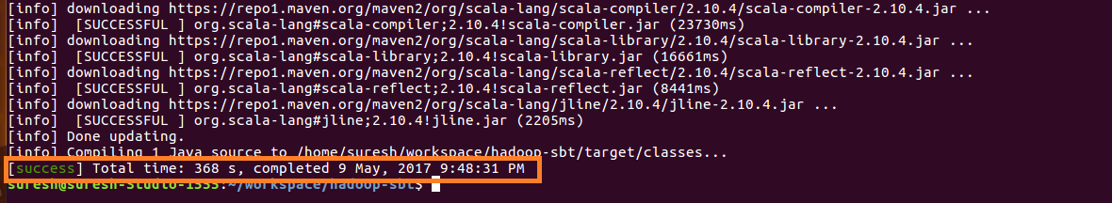

After compiling, if the project doesn’t have any errors then we can see a success message at the last.

SBT Eclipse command:

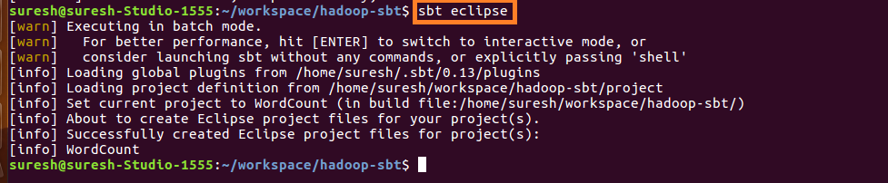

SBT Package command:

This command will create the jar file inside the target folder

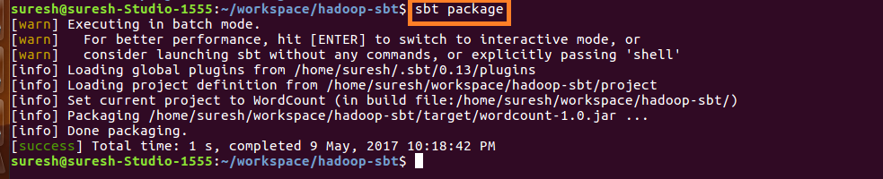

Jar file is created inside the target folder

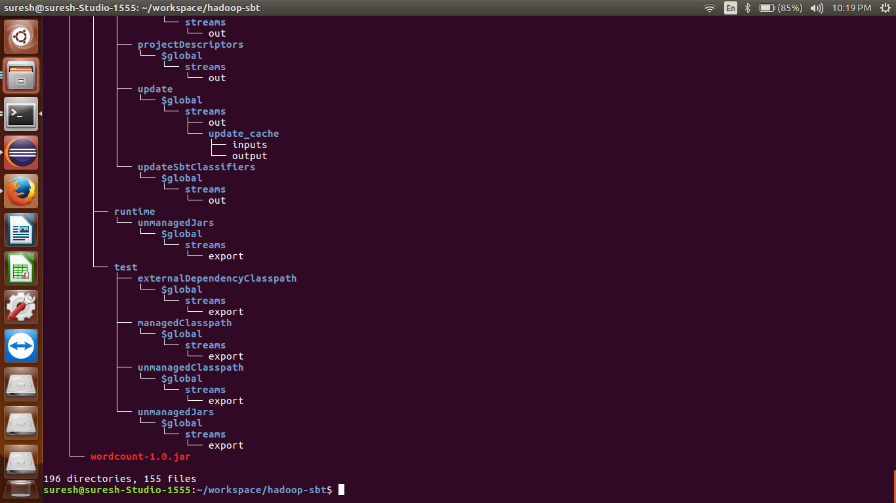

Running jar:

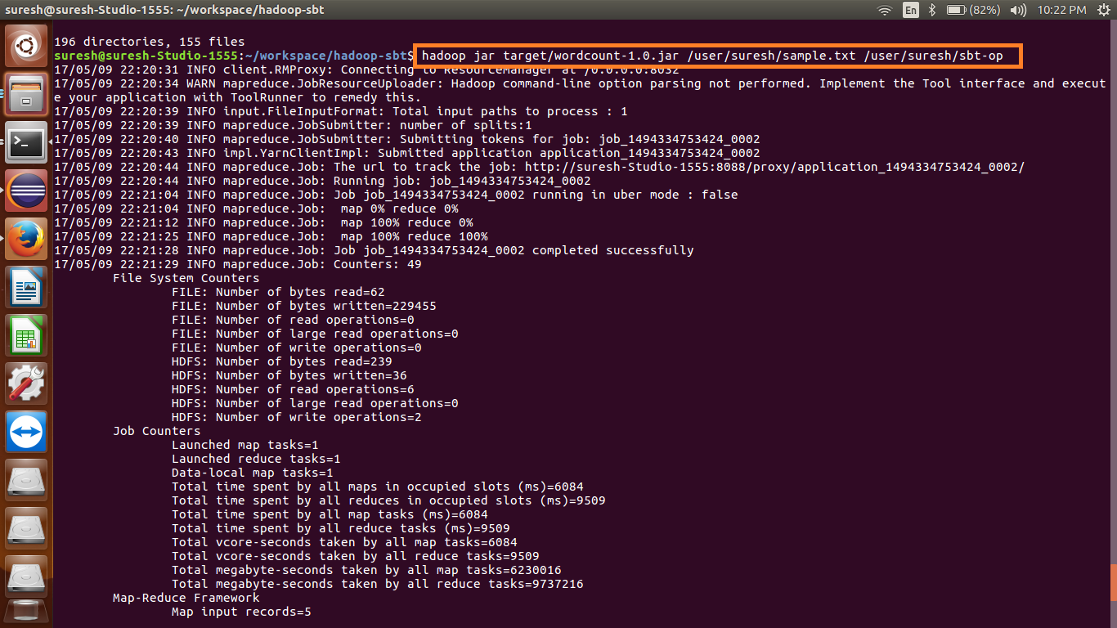

Output:

